User Guide

**\*How to access each feature**

-feature 1 : reward

-there is reward section in the app

-the app is programed for user to get motivate. user can get reward with their points

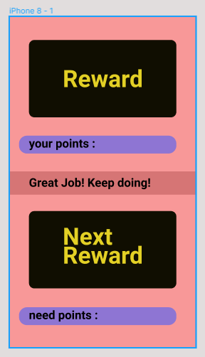

-feature 2 : Q&A

-user can leave message

-faculty in charge will answer the question

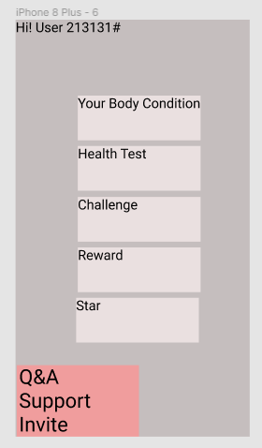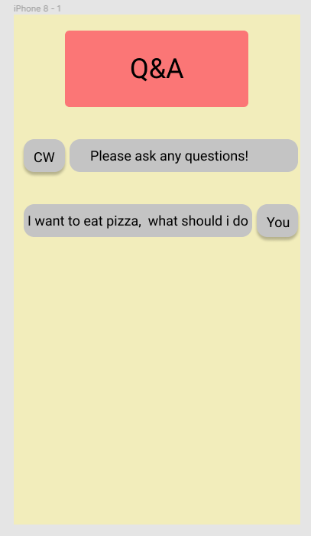

**\*How to use each feature**

-feature 1 : reward

-there is activity mission in the app, when user accomplish the mission,

points are given. with that points user can get reward. reward can be diverese.

-feature 2 : Q&A

-there is Q&A section in the app, when user leave the message, our faculty reply.

-user can get professional advice from health expert.